RTP work protocol

- All users must work with tools BOOKIT and Logbook.
- Maximum wafer size - 4 inches.
- Extremely critical use Coolin Water.
- Before process make sure the heated material will not evaporate and not contaminate the Chamber and Quartz window.
- Be careful, quartz pins are fragile.
- For substrate table use calibrated Si wafers 500±25mcm ID 1095 in Recipe Chart named “Pyrometer calibration table SiWaf4inV4”.
- Do not open the Chamber until Cooling after the process is not finished.
- Do not exceed the following process durations:
Maximum Rate Up – 100
T≤500°C – 30min
T≤700°C – 10min
T≤900°C – 3min

RTP Manual
- Open two Cooling Water Taps (pic.1).
- Open Compressed Air (pic.2).
- Switch ON General Breaker on the back side of the machine (pic.3).
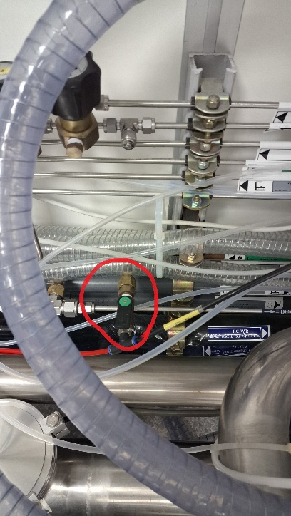
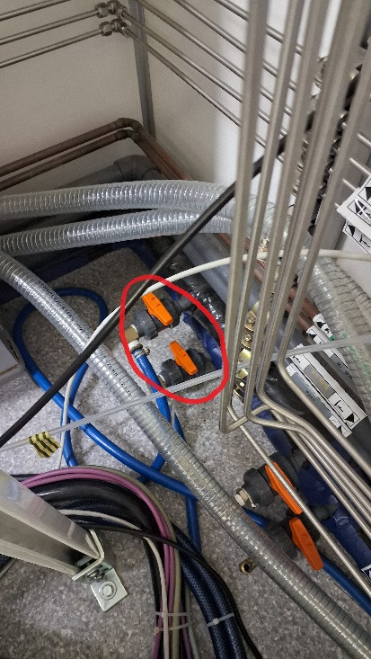

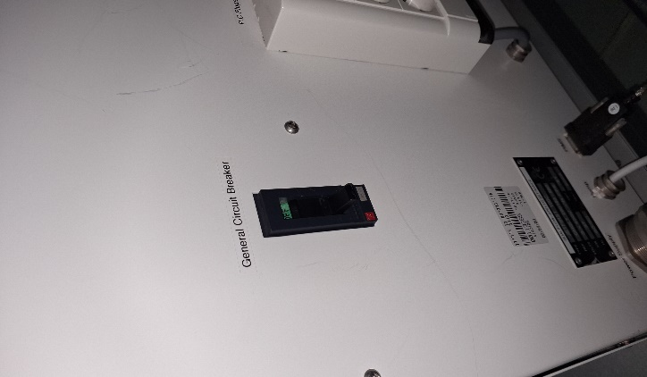

Pic.1 Pic.2 Pic.3
- Start computer end enter with password “2012”.
- Start the RTP program and press “Logic I/O”.
- Start Fore-Vacuum pump by pressing Green button on Front Panel.
- In Parameters tab click Maintenance button and then Inputs/Outputs button.
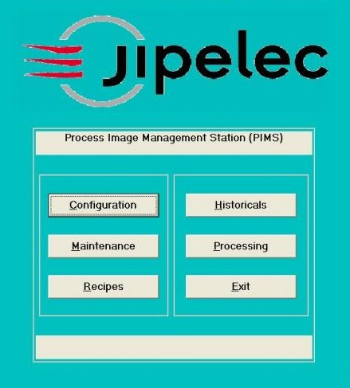

- Inputs/Outputs Status window will open. Make sure that all of boxes are GREEN or BLACK. In case of one of them is RED contact to the FAB staff.

- Return one step Up and press VACUUM button. Interactive synoptic Vacuum circuit will open.

- Run Low/High Vacuum sequences to make sure that readouts of vacuum gauges, gas flows and valves status are correct. Good operation provides that Fore-Vacuum and Turbo pumps work and small squares inside are white, and TGV is open.
10. Return to the Process Image Management Station window and press the Processing button. “Recipe to download” window will open. Start with “1_Pyro650C_worming” program before your recipe.
- When you finish your job, stop the Fore-Vacuum Pump and close the program. Close Compressed Air and Cooling Water. Switch down General Breaker on the back side of the machine.

