Estrales
Choose only 2
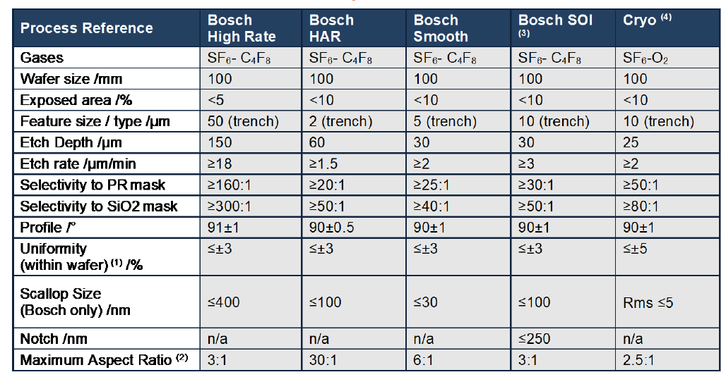
Main specifications
- Gases- SF6, C4F8,O2
- 4’’ wafer, 7mm edge clamp
- ER up tp 1.5(um/min) for HAR
- Selectivity- more than 20:1 to PhR, 40:1 to SiO2
- ~Profile 90 deg
- Uniformity - ~5%
- Scallop- 5nm(Cryo)
Requirements-
Bosch process- alternating deposition and etch step, interleaved clean regime (plasma, mechanical )
Feature size- 10um width, AR 1:1, depth<1um, 20% exposed area
Mask sidewall profile- >87%
PhR- AZ45662,S1818…
Mask thickness- 2XEtch depth/selectivity
Calculations:
Etch depth- * wafer uniformity- $\frac{max-min}{2*Avg}*100\%$
* Batch uniformity – $\frac{\max\left(avg\right)-\min\left(avg\right)}{2*Avg}*100\%$
* Reproducibility (run to run) uniformity – $\frac{\max\left(avg\right)-\min\left(avg\right)}{2*Avg}*100\%$

