Safety and Work Protocol for ​​ Profilometer Dektak XT:
Only Trained and Authorized Users are Allowed to Operate the System !
- Always use only dry samples!
- Clean the sample with nitrogen prior to measurements.
- Never set the scan speed lower than 50 $μm/sec$; always aim for a speed around 100 $μm/sec$.
- Perform scans strictly within the sample limits; never start the scan outside the sample and move onto it, as this may damage the tip.
- Always position your sample on the stage while the tip is raised!
- Always remove your sample after the tip is raised!
- Reduce the light source intensity after completing your work.
- Scanning occurs in one direction, from your side to the opposite side. Keep this in mind to stay within the sample boundaries.

For any questions, call 79812/ 08-6479812 Tania

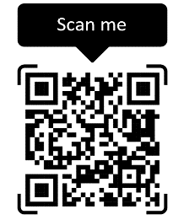

For any problems

