Safety and Work Protocol for ​​3D Laser Microscope – LEXT:

Only Trained and Authorized Users are Allowed to Operate the System !
- Allow the system to automatically initialize upon startup, ensuring no sample is present.
- Handle the microscope with care to prevent damage to delicate parts, especially the stage and lenses.
- Ensure that no objects touch the microscope's objectives, especially at high magnifications (x50 and x100).
- Do not switch the optical objectives directly to high magnifications (x50 or x100); instead, change them progressively while making focus adjustments.
- Switch the objective to x5 before removing the sample.
- Avoid touching the optical components or microscope lenses.
- At the end of your work, safely shut down the microscope by closing the software (do not leave the light source on!).
- Be aware that the system does not measure transparent materials accurately, which may distort the results if any are present.
- Do not use a green filter in combination with the laser.
- If the system exhibits any malfunction, or if you encounter problems during use, immediately stop the process and notify the tool owner.

For any questions, call 79812/ 08-6479812 Tania

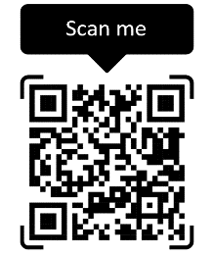

For any problems

