Safety and work protocol for JEOL SEM:

- Do not insert a sample larger than 3 x 3 cm or taller than the height of the load lock.
- Do not insert degasses materials.
- Load the sample into the specimen chamber, ensuring that the load lock door is properly closed and sealed before proceeding.
- Initialize the vacuum system and verify that the pressure reaches the required level (E-4) before inserting the sample into the chamber.
- Select the holder, set the sample height, and enter the project name in the software
- Adjust the microscope parameters (e.g., accelerating voltage, working distance) according to the sample type and desired imaging conditions.
- Choose the appropriate detector modes (e.g., secondary electron, backscattered electron) based on the sample's surface properties.
- Always monitor the sample and SEM display while the system is in operation, especially when changing the working distance (WD) or tilt.
- Be aware of potential issues, such as electron beam drift or specimen damage due to excessive exposure.
- For EDS analysis Set Working Distance to 10 mm and use Stage-Z to focus if necessary.
- Do not use BD mode when tilt is on.
- Do not insert the BSE detector when the WD is less than 3 mm.
- Before removing the sample from the chamber, ensure it is returned to the load lock exchange position.
- When the work is finished, the electron beam valve must be closed and turn off the light in the chamber.
- Do not change any settings other than voltage, WD, detector, focus, current, and stigmatization.

For any questions, call 79812/ 08-6479812 Tania

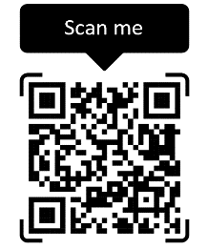

For any problems

