Spinner
80RC Universal Spin Coating System Delta
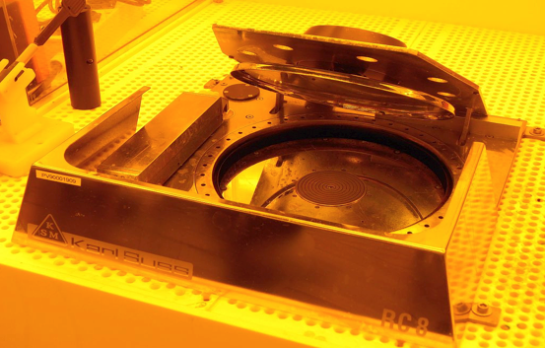
Machine description
Spin coating for deposition uniform thin films to flat substrates.

Materials
All kinds of photoresists and thin films.

Main specifications
Maximum RPM: 5000
Max sample size: 4” round or square

For more information: https://www.suss.com/

